Assignment-02

Shell Scripting Assignment

**Name:** Tanishq Kanare

**Date:** 21/7/24

1. Write a shell script to find whether a given year (4 Digits) is leap year or not.

Ans. 1) The shell script is as follows: -

nano leap.sh

read -p "Enter a year (4 digits): " year

if ! [[ $year =~ ^[0-9]{4}$ ]]; then

echo "Please enter a valid 4-digit year."

exit 1

fi

if (( (year % 4 == 0 && year % 100 != 0) || (year % 400 == 0) )); then

echo "$year is a leap year."

else

echo "$year is not a leap year."

fi

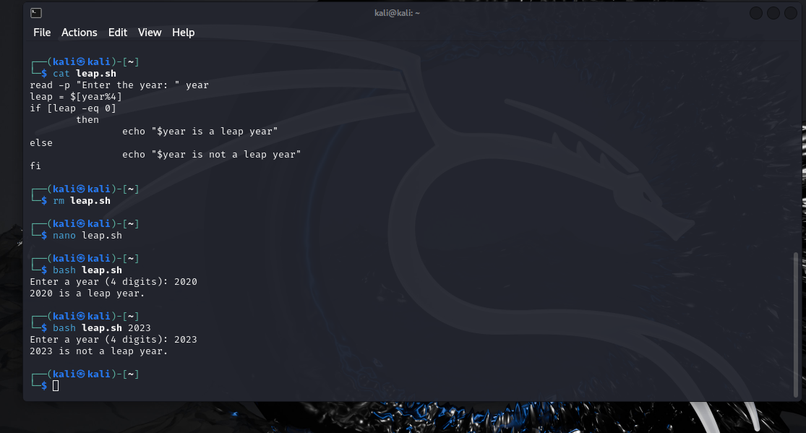

1. Write a shell script to find the multiplication of first 5 numbers.

ANS. 2) The shell script is as follows: -

nano pro.sh

result=1

for i in {1..5}

do

result=$((result * i))

done

echo "The multiplication of the first 5 numbers is: $result"

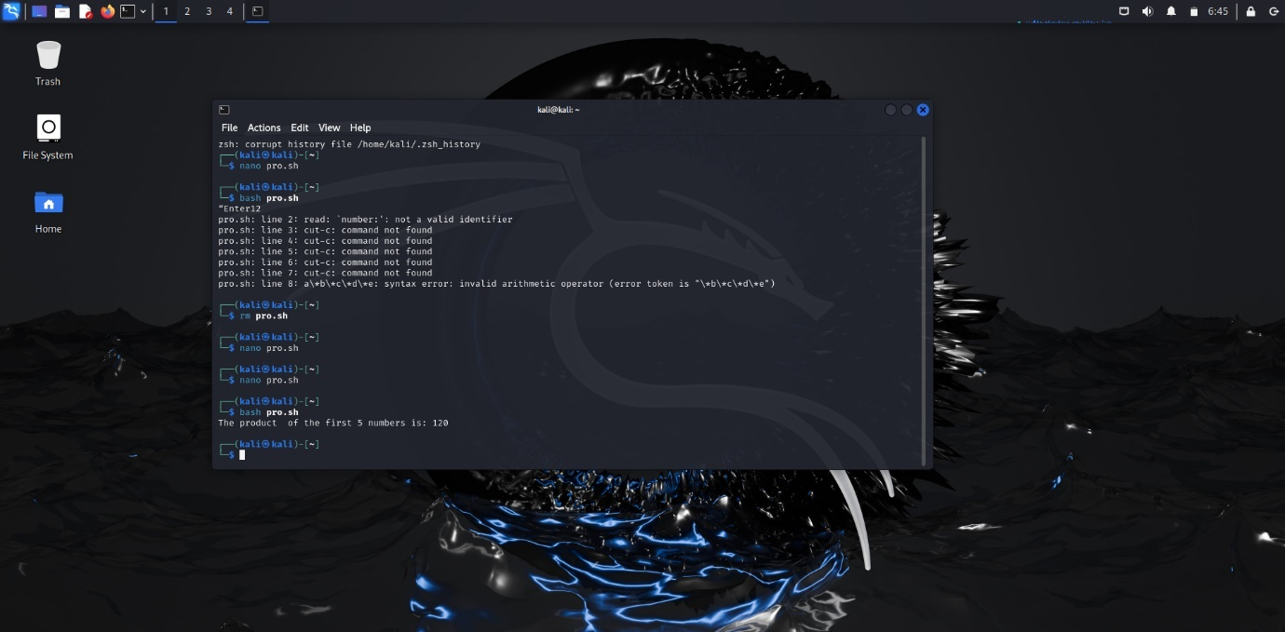

1. Write a shell script to check if whether a given number is prime or not.

ANS. 3) The shell script is as follows: -

vi prime.sh

read -p “Enter the number: ” num

if [$num -lt 1]

then

echo “$num is not a prime number”

fi

if [$((num%2)) -eq 0]

then

echo “$num is not a prime number”

fi

for (i=3; i -le $((num\*0.5)); i+2)

do

if [$(num%i -eq 0)]

then

echo “$num is not a prime number”

fi

done

echo “$num is a prime number”

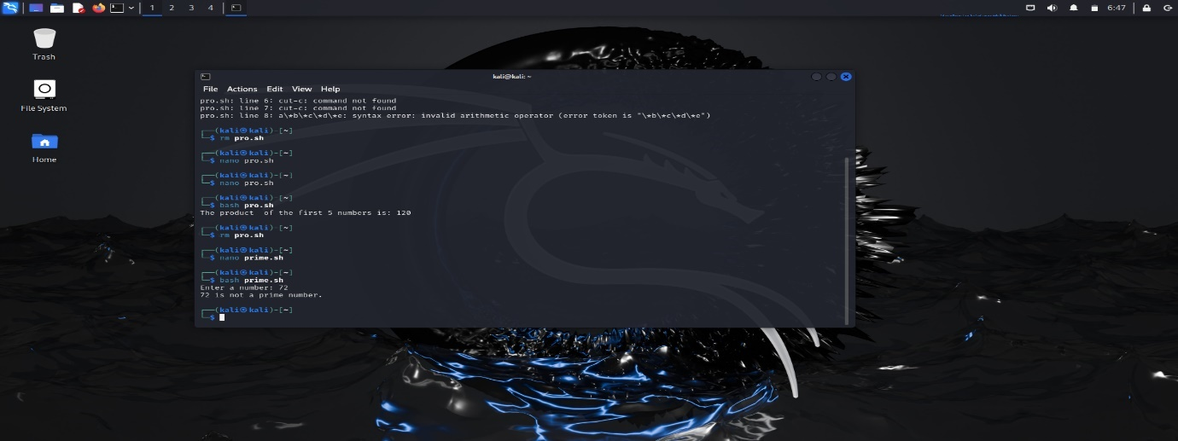

1. Write a shell script to check if whether a given number is Armstrong or not

Ans. 4) The shell script is as follows: -

vi arm.sh

read -p “Enter a number: ” num

arm=0

while [$num -ne 0]

do

r=$[num%10]

arm=$[arm+r\*r\*r]

n=$[num%10]

done

echo “The evaluated value is $arm”

if [$arm -eq $num]

then

echo “$num is an Armstrong number”

else

echo “$num is not an Armstrong number”

fi

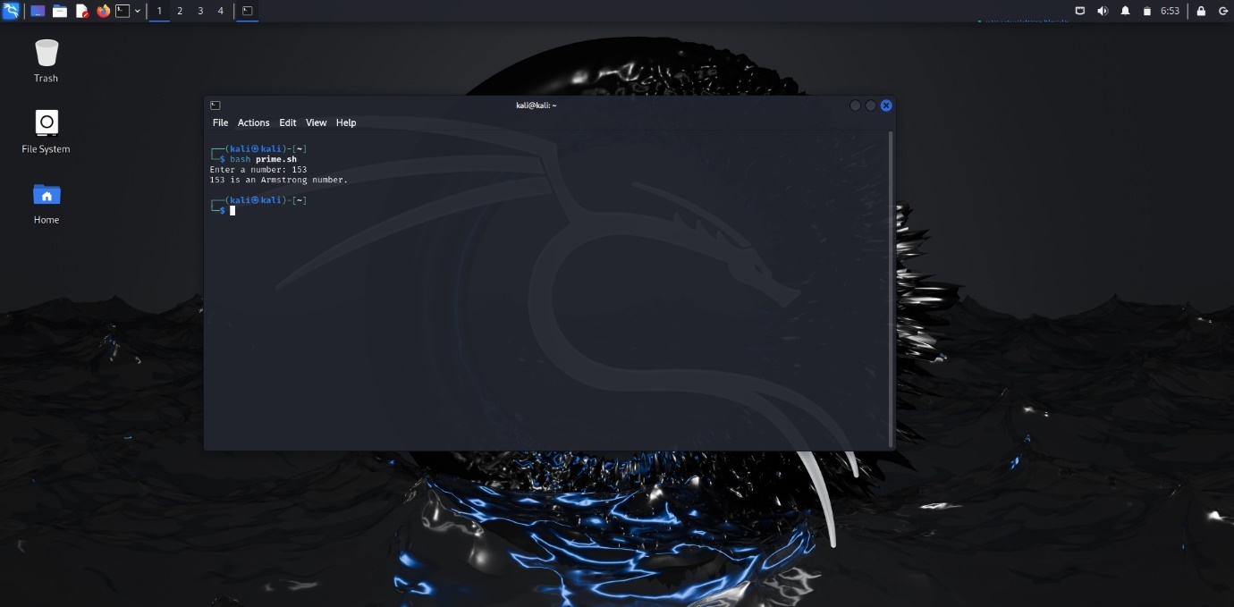

1. Write shell script to create user oriented calculator (use case, while loop, etc)

ANS. 5) The shell script is as follows: -

while true; do

echo "Calculator:"

echo "1. Add"

echo "2. Subtract"

echo "3. Multiply"

echo "4. Divide"

echo "5. Exit"

read -p "Select an option (1-5): " choice

if [ "$choice" -eq 5 ]; then

echo "Exiting. Goodbye!"

break

fi

read -p "Enter first number: " num1

read -p "Enter second number: " num2

case $choice in

1) result=$((num1 + num2)); echo "$num1 + $num2 = $result" ;;

2) result=$((num1 - num2)); echo "$num1 - $num2 = $result" ;;

3) result=$((num1 * num2)); echo "$num1 * $num2 = $result" ;;

4)

if [ "$num2" -ne 0 ]; then

result=$((num1 / num2))

echo "$num1 / $num2 = $result"

else

echo "Division by zero is not allowed."

fi

;;

*) echo "Invalid option. Please try again." ;;

esac

done

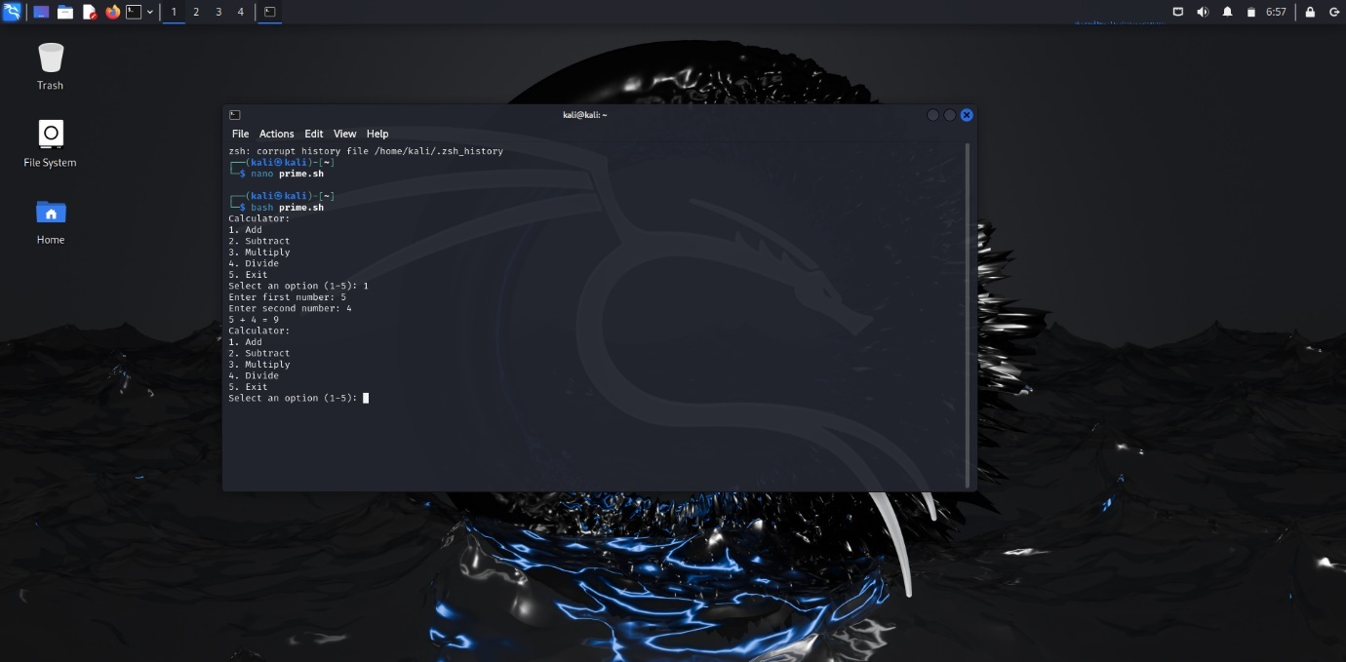

1. Get a value in variable N, and make a table and display on screen, liken=5, 5*1… 5*10=50

ANS. 6) The shell script is as follows: -

read -p “ Enter the number: ” n

i=1

while [$i -le 10]

do

res= `expr $i\*$n`

echo “ $n x1 = $res”

let i++

done

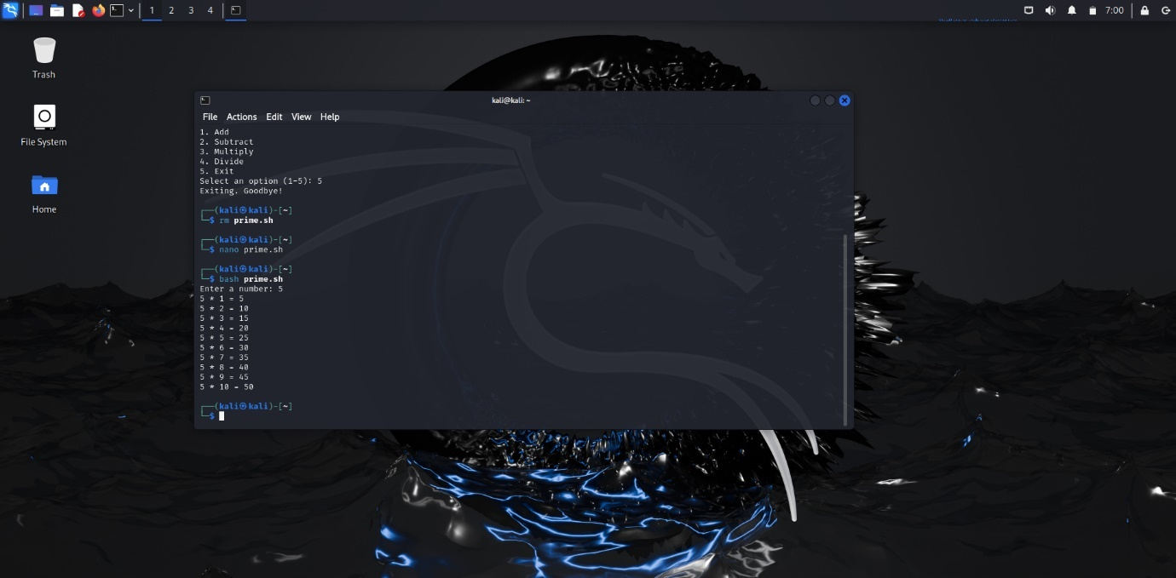

1. Write a shell script to calculate Simple interest and compound interest.

ANS. 7) The shell script is as follows: -

# Read inputs from the user

read -p "Enter principal amount: " principal

read -p "Enter annual interest rate (in percentage): " rate

read -p "Enter time (in years): " time

read -p "Enter number of times interest is compounded per year: " frequency

if [ "$principal" -le 0 ] || [ "$rate" -le 0 ] || [ "$time" -le 0 ] || [ "$frequency" -le 0 ]; then

echo "All values must be positive integers."

exit 1

fi

simple_interest=$((principal * rate * time / 100))

echo "Simple Interest: $simple_interest"

amount=$principal

for ((i = 0; i < time * frequency; i++)); do

amount=$((amount + amount * rate / (100 * frequency)))

done

compound_interest=$((amount - principal))

echo "Compound Interest (approximate): $compound_interest"

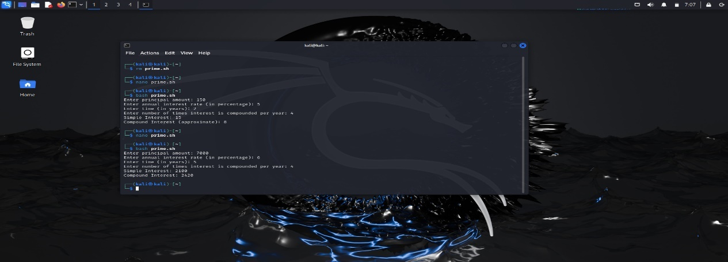

1. Display series: 0+4+27+256+….

ANS. 8)

read -p "Enter the number of terms in the series: " terms

if [ "$terms" -le 0 ]; then

echo "Please enter a positive integer."

exit 1

fi

series=""

sum=0

for ((i = 0; i < terms; i++)); do

term=$((i ** i))

series+="$term"

sum=$((sum + term))

if [ $i -lt $((terms - 1)) ]; then

series+="+"

fi

done

echo "Series: $series"

echo "Sum: $sum"

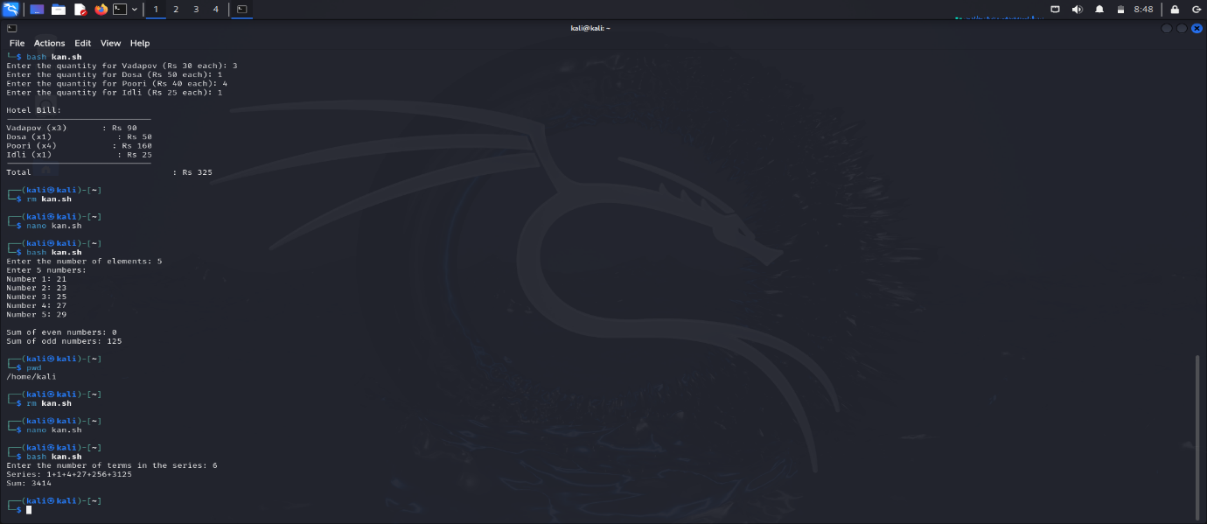

1. 1 generate the pattern given below, read n and then generate. 2 3

4 5 6

7 8 9 10

ANS. 9)

read -p “ Enter the number of rows up-to which you want the pattern: ” N

start =1

for (row=1; row -le N; row++)

do

for (col =1; col -le $row; col++)

do

echo -n “$start”

start =$[start +1]

done

done

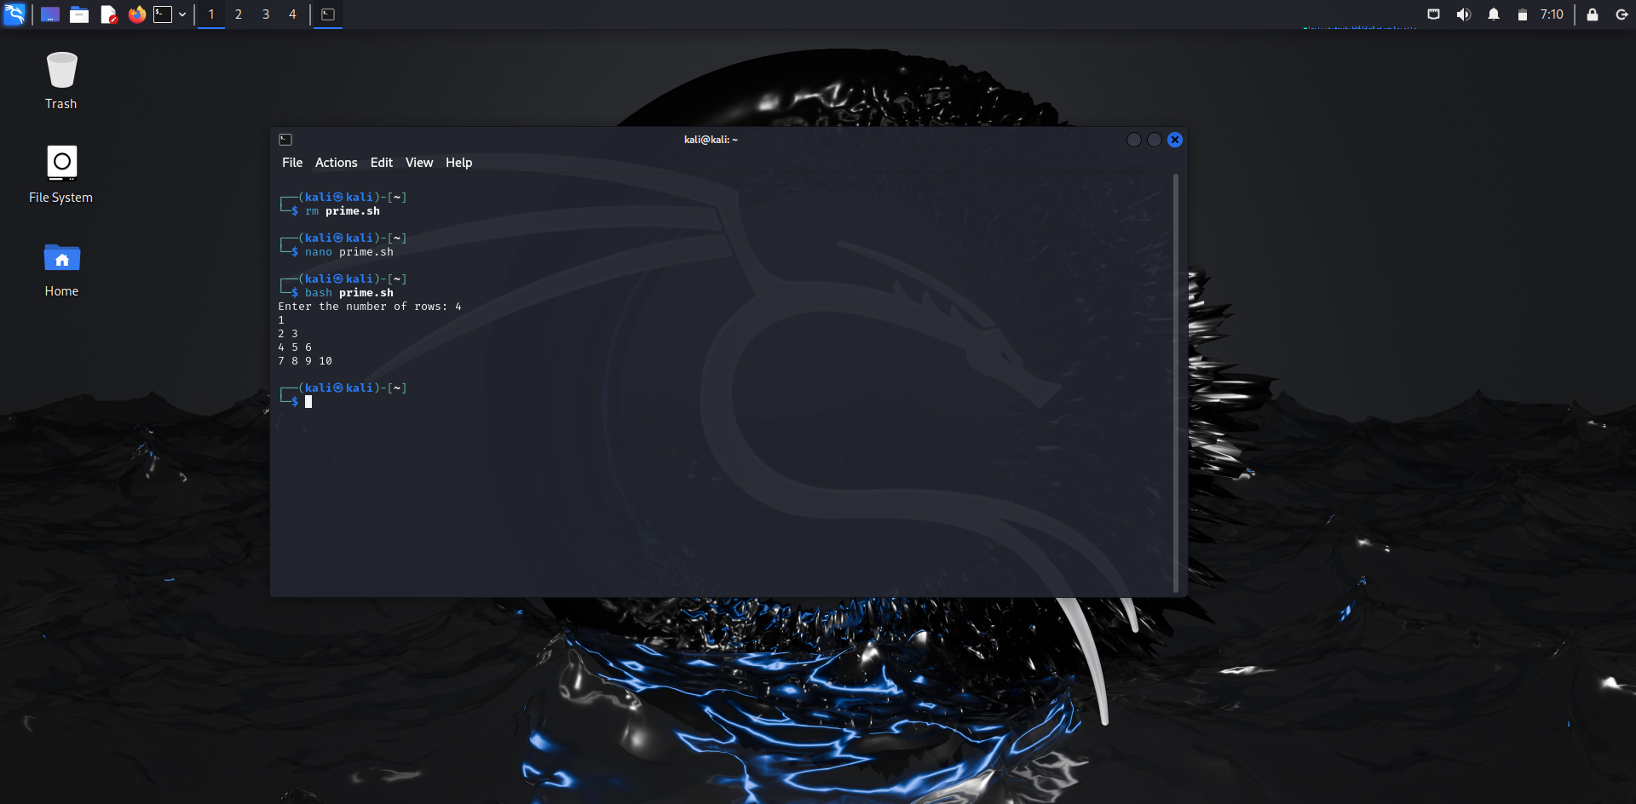

1. Write a script to print a given number in reverse order like get 12345 and o/p is 54321

ANS. 10)

read -p “Enter the number to be reversed: ” N

num=0

while [$n -gt 0]

do

num =$(`expr $num \*10)

k=$(`expr $n%10)

num =$(`expr $num + $k)

n=$(`expr $n/10)

done

echo “Reversed number is $num”

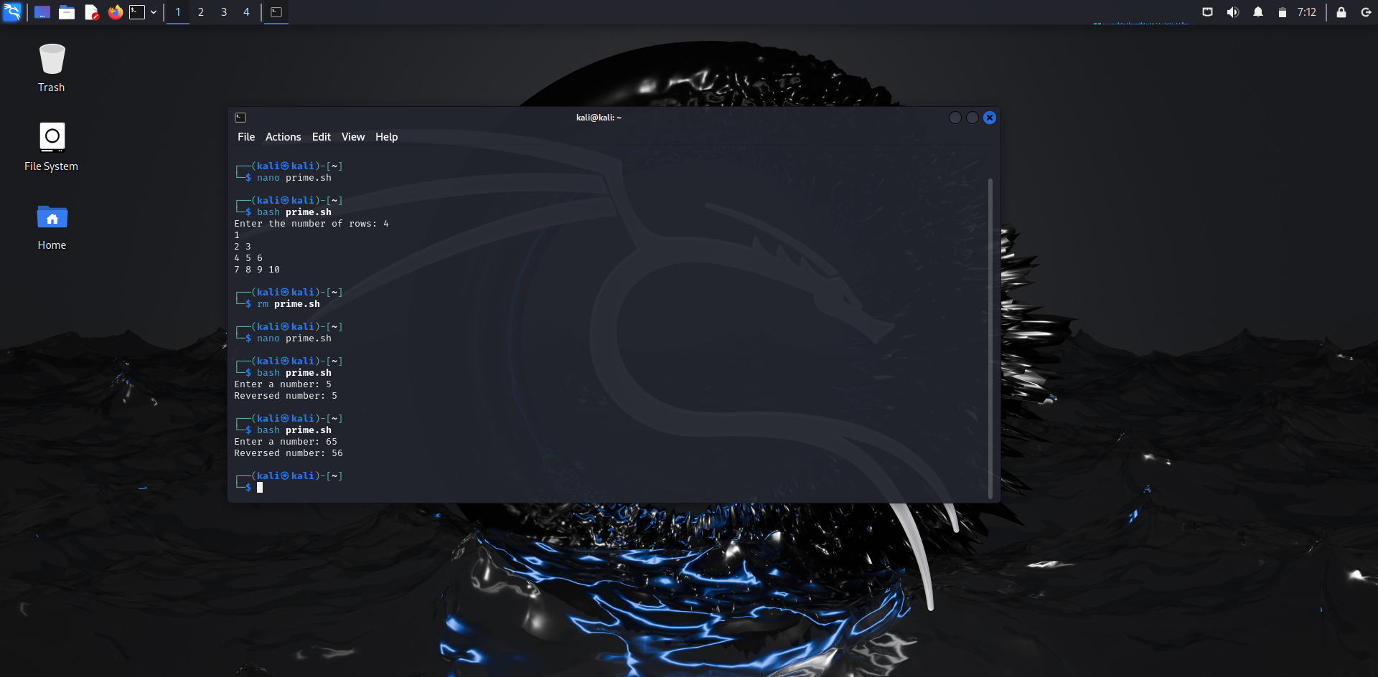

1. Write a script to delete empty lines from a file

ANS. 11) For example we have file abc.txt

abc.txt contains the following content:

Tanishq

KANARE

Student

By using grep command, we can remove the empty lines from the file:

grep -v '^$' abc.txt > stu.txt

This command will created a new stu.txt file and the contents of this file are without empty lines which are as follows:-

Tanishq

KANARE

Student

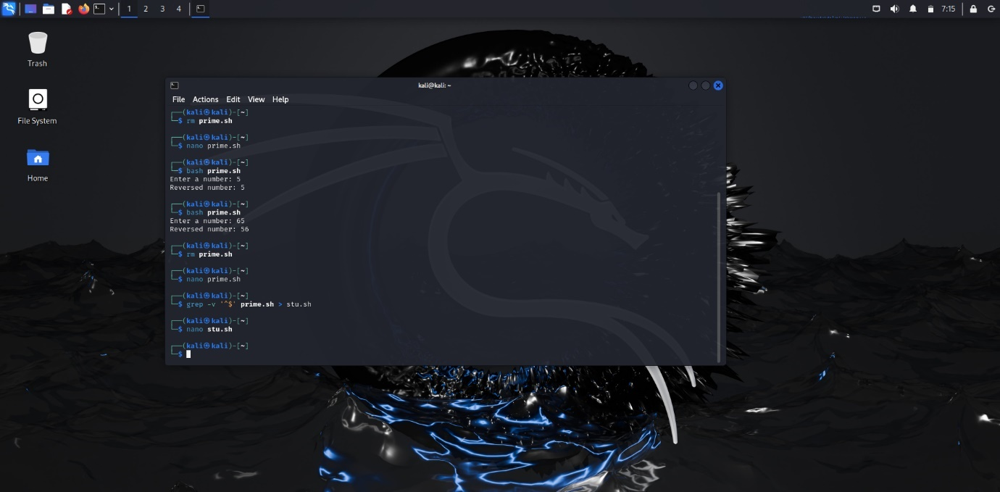

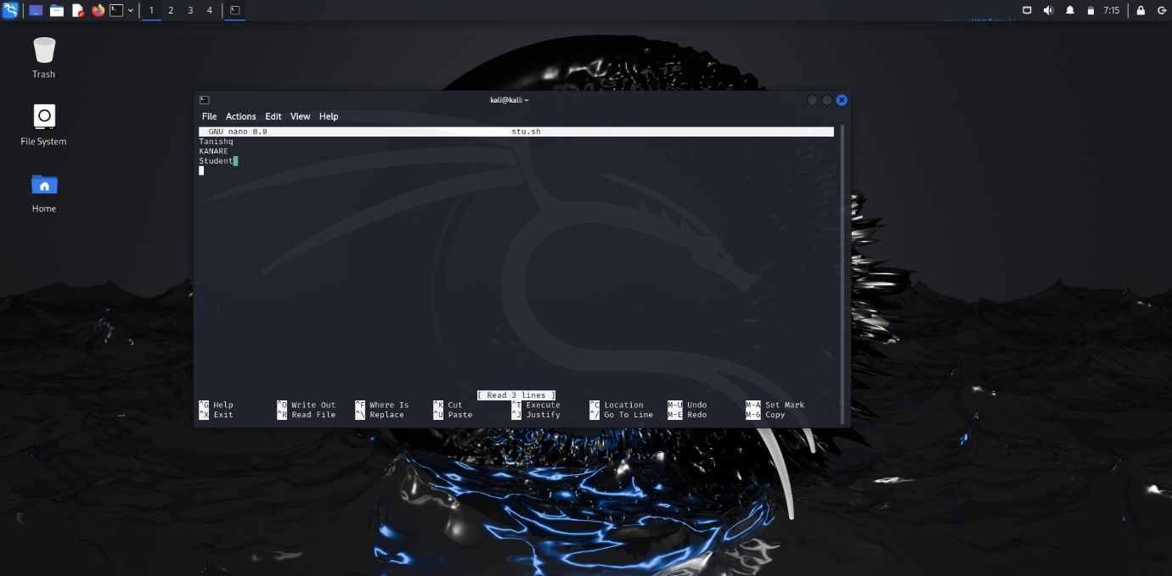

1. Write a script to print the length of each and every string using arrays

ANS. 12)

read -p “Enter the number of strings: ” k

strings=()

for ((i=0; i<k; i++));

do

echo “Enter the string $((i+1)): ”

read -r string

strings+=(“$string”)

done

echo “Lengths of the entered strings: ”

for str in “${strings[@]};

do

length=${#str}

echo “Length of $str: $length”

done

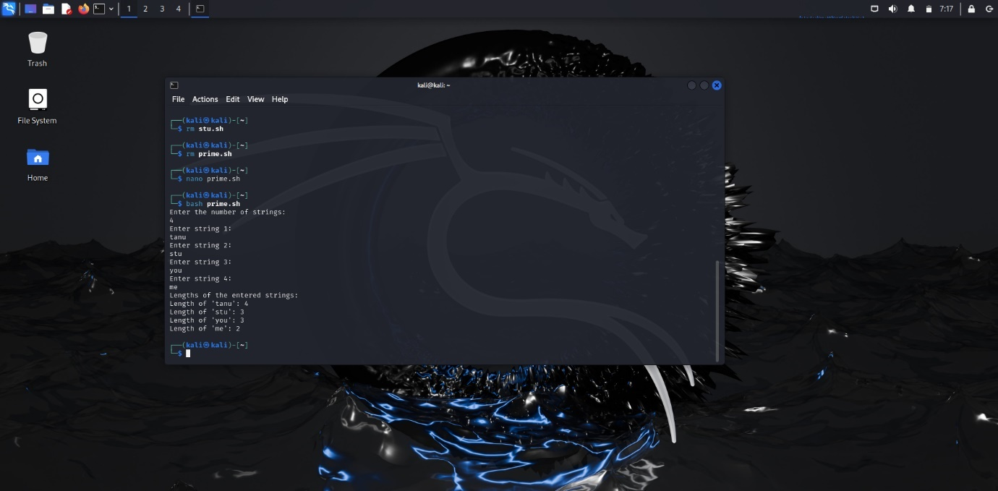

1. Write a script to print the following system information,

Currently logged users

1. Your shell directory
2. Home directory
3. OS name & version
4. Current working directory
5. Number of users logged in
6. Show all available shells in your system
7. Hard disk information
8. CPU information
9. Memory information
10. File system information

Currently running process

Answers :

$Who

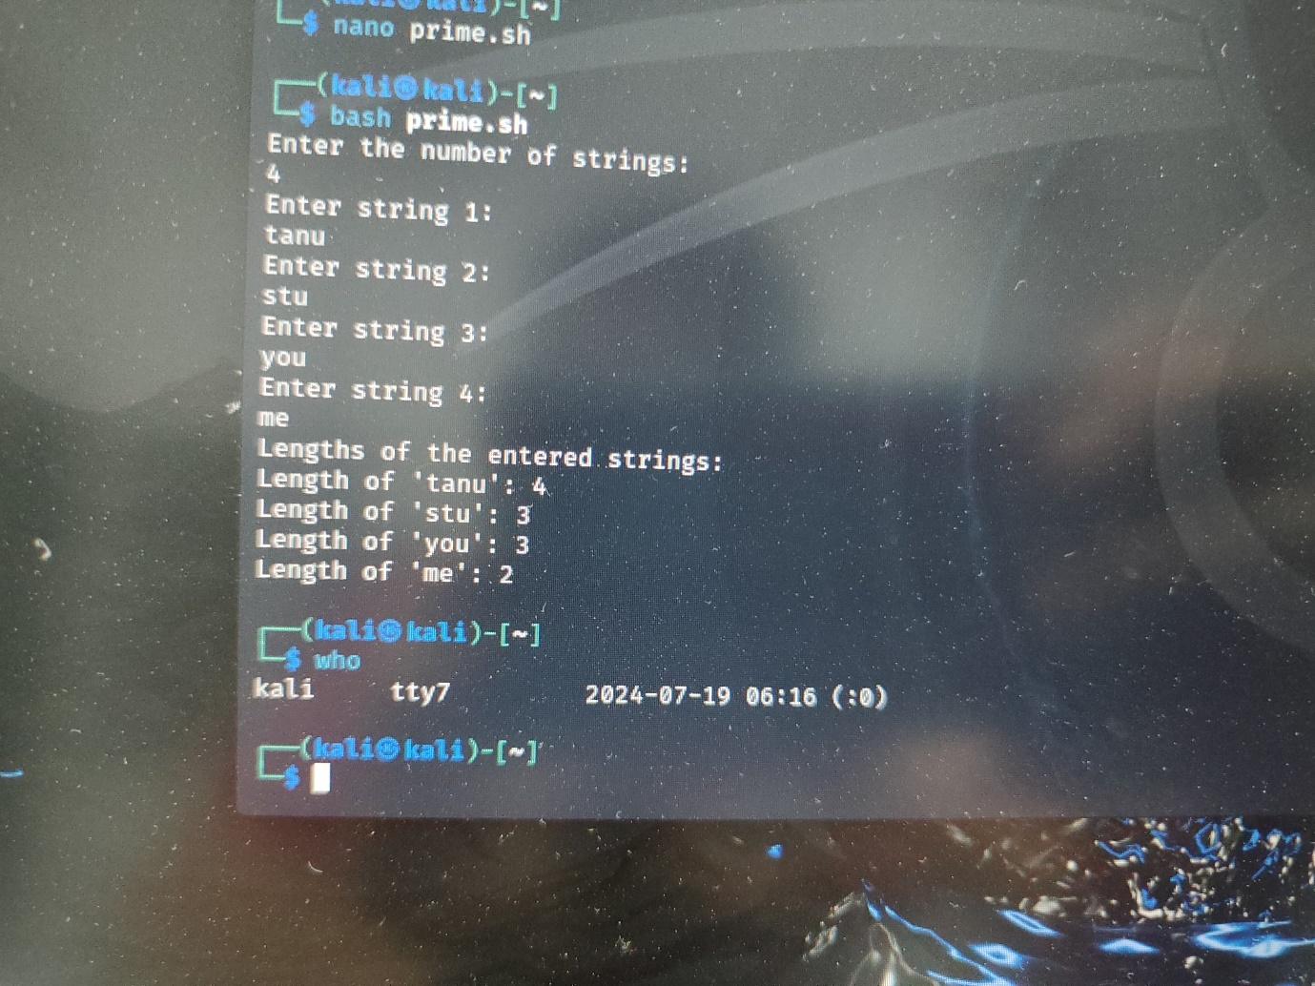

1. echo $shell

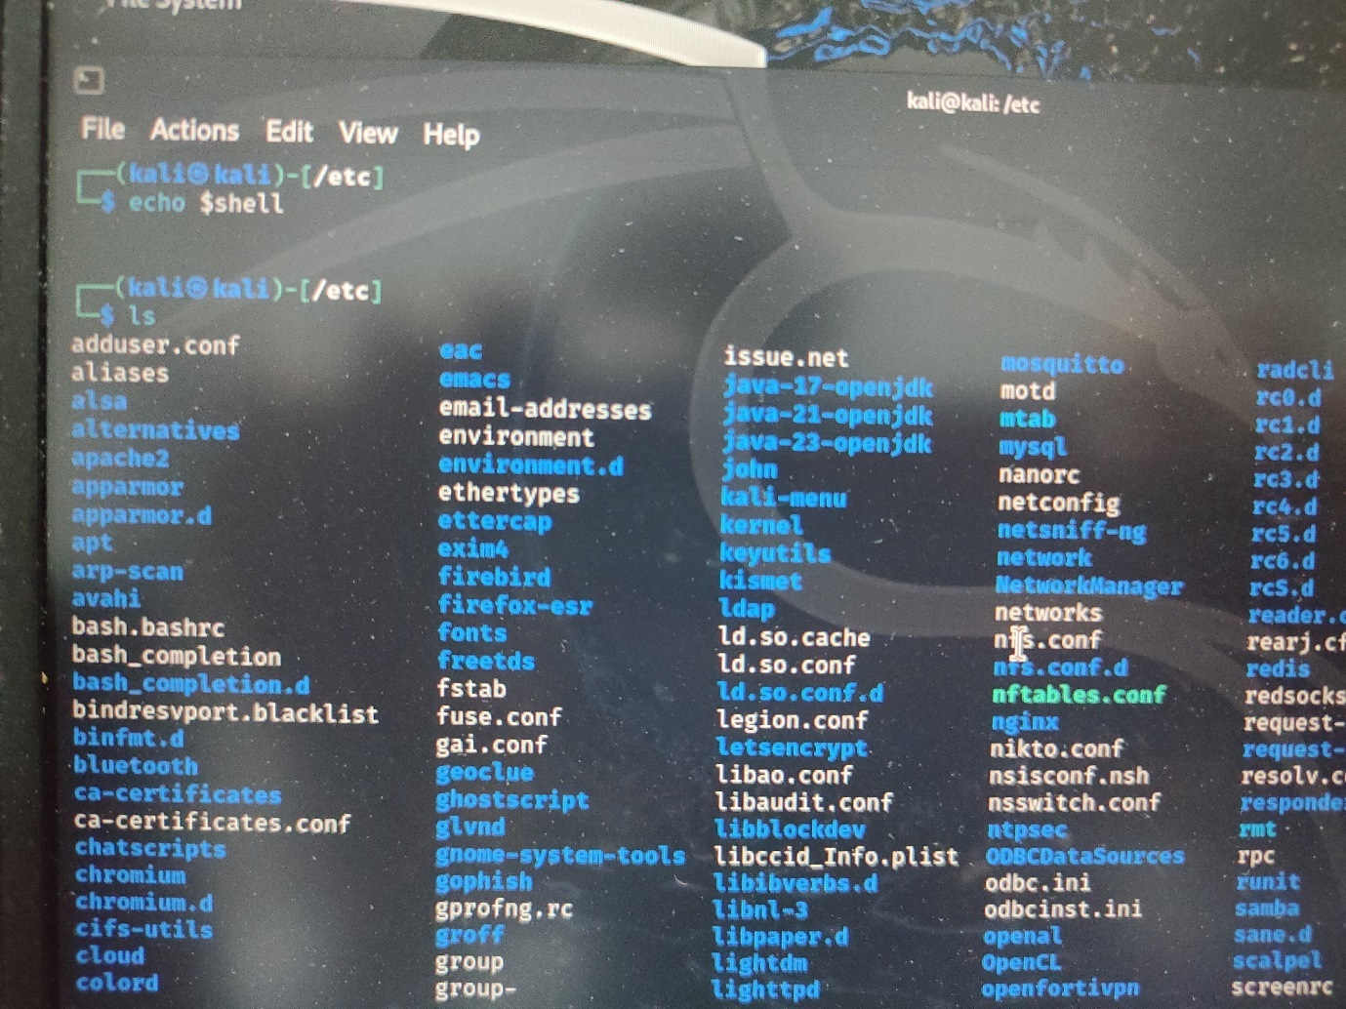

1. echo $home

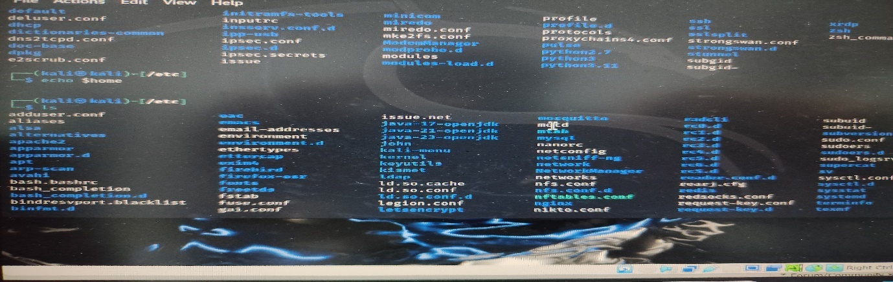

1. uname -srm

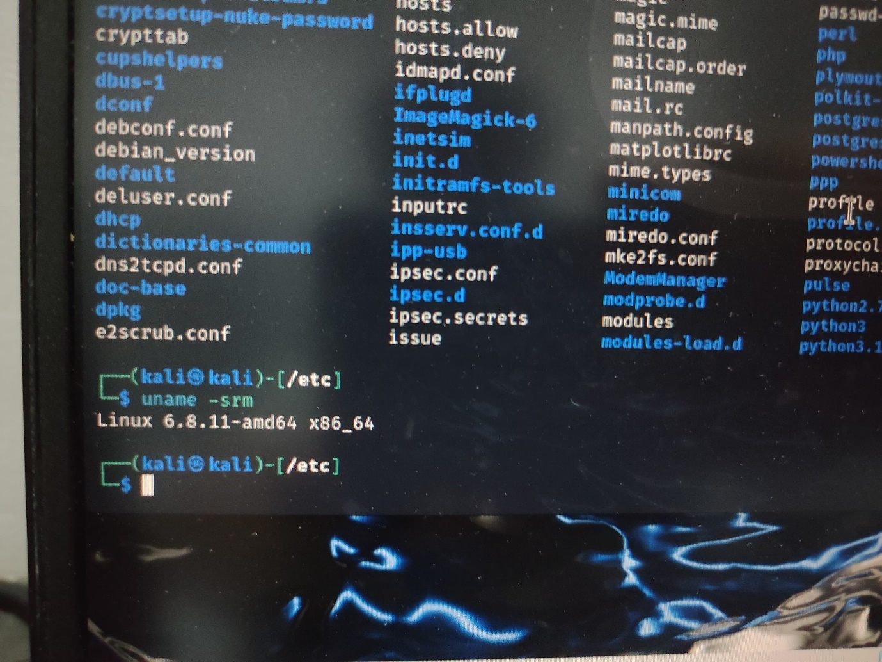

1. pwd

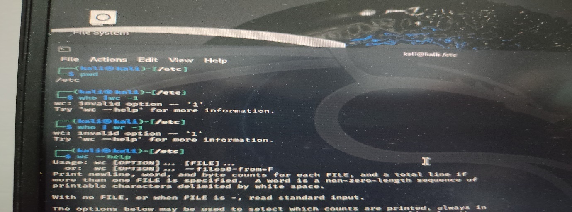

1. who | w

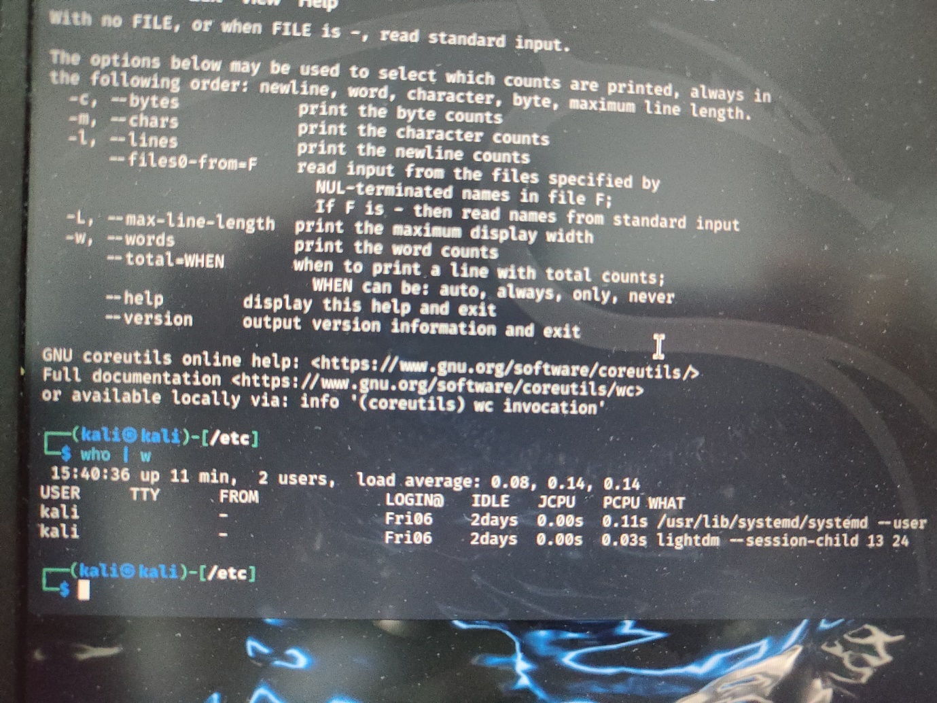

1. cat /etc/shells

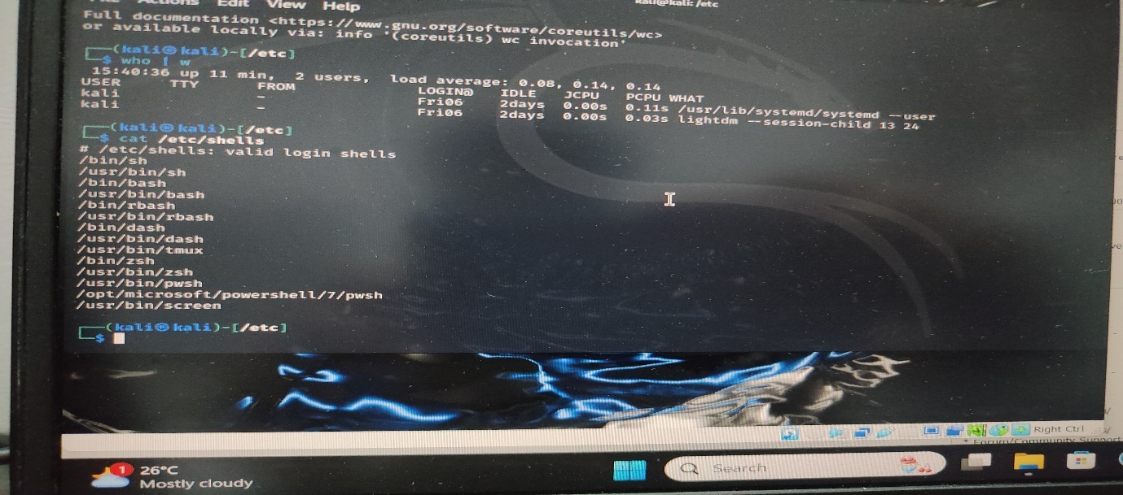

1. df -h

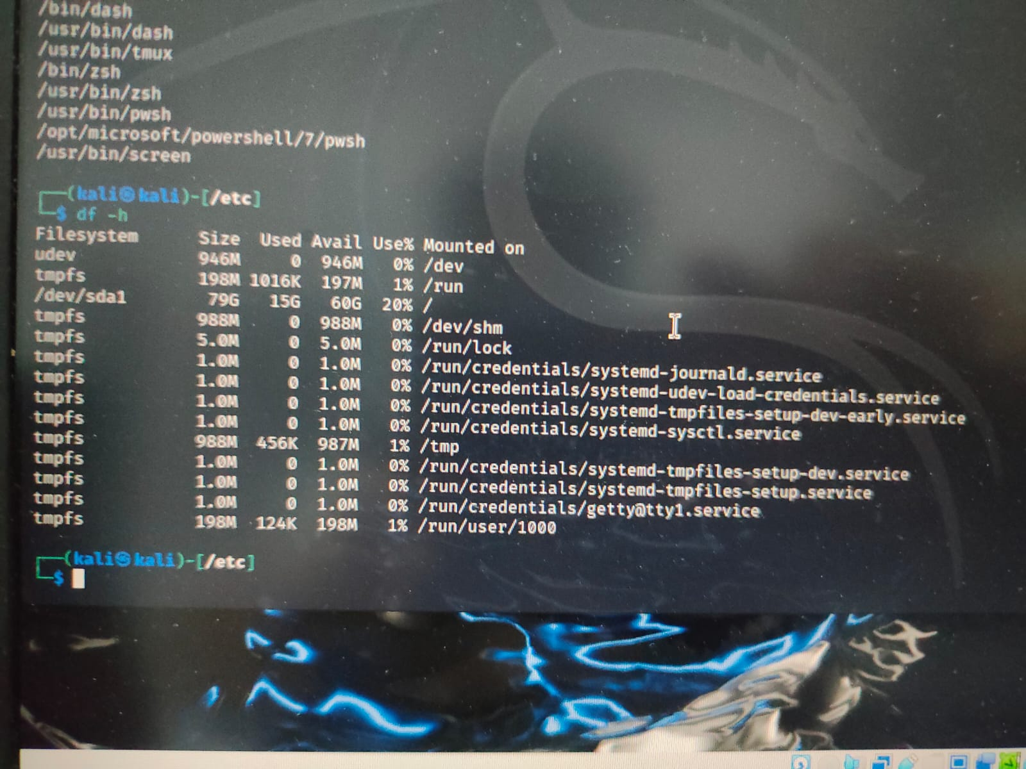

1. lscpu

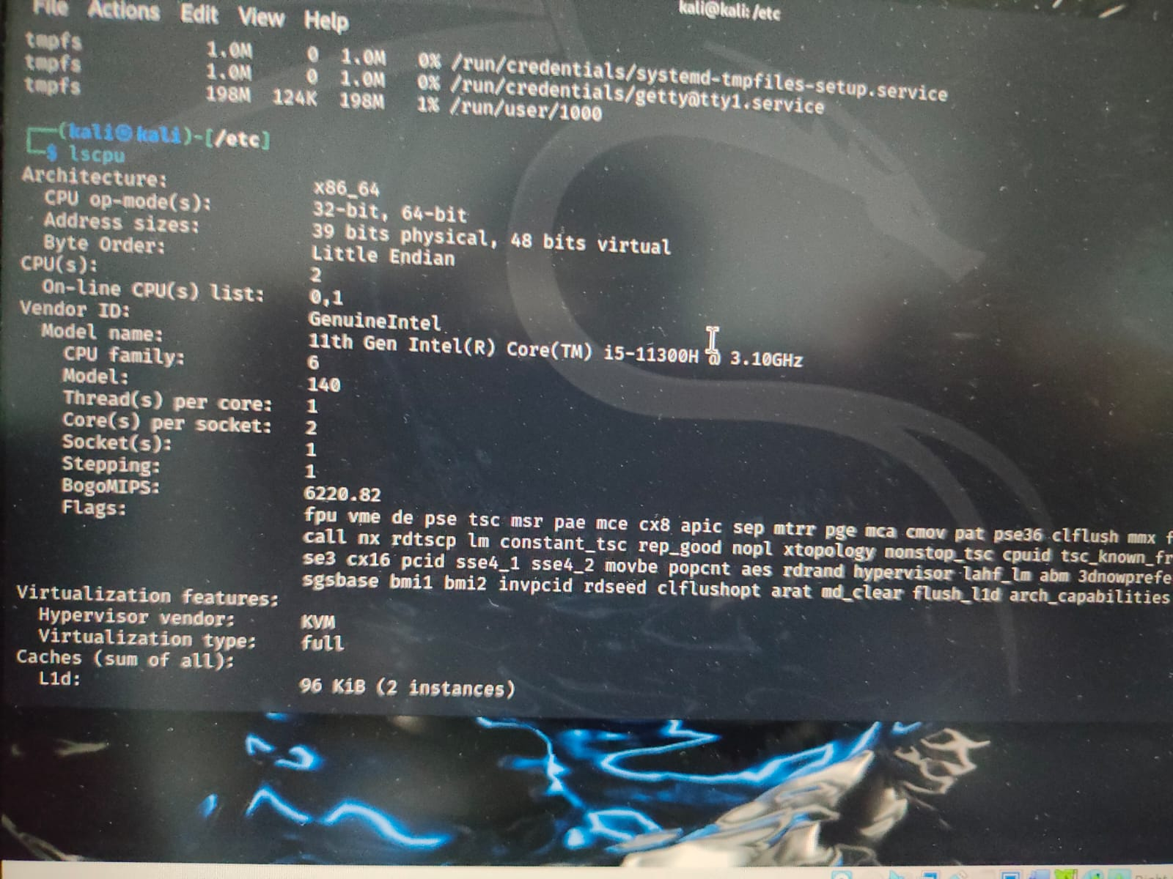

1. free -h

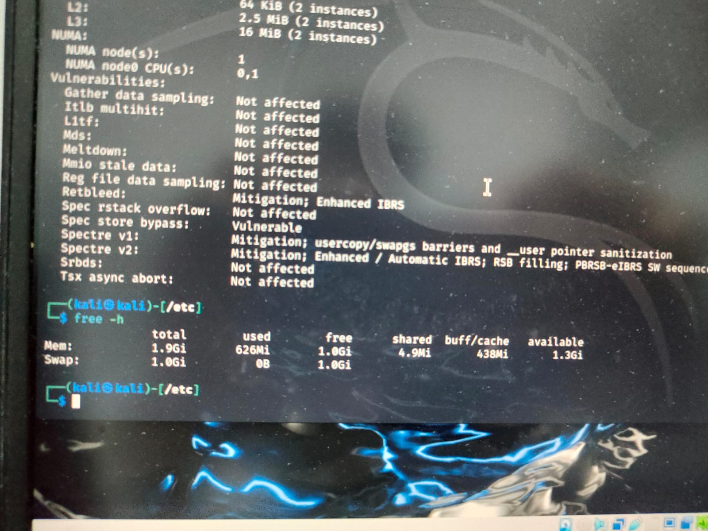

1. lsblk

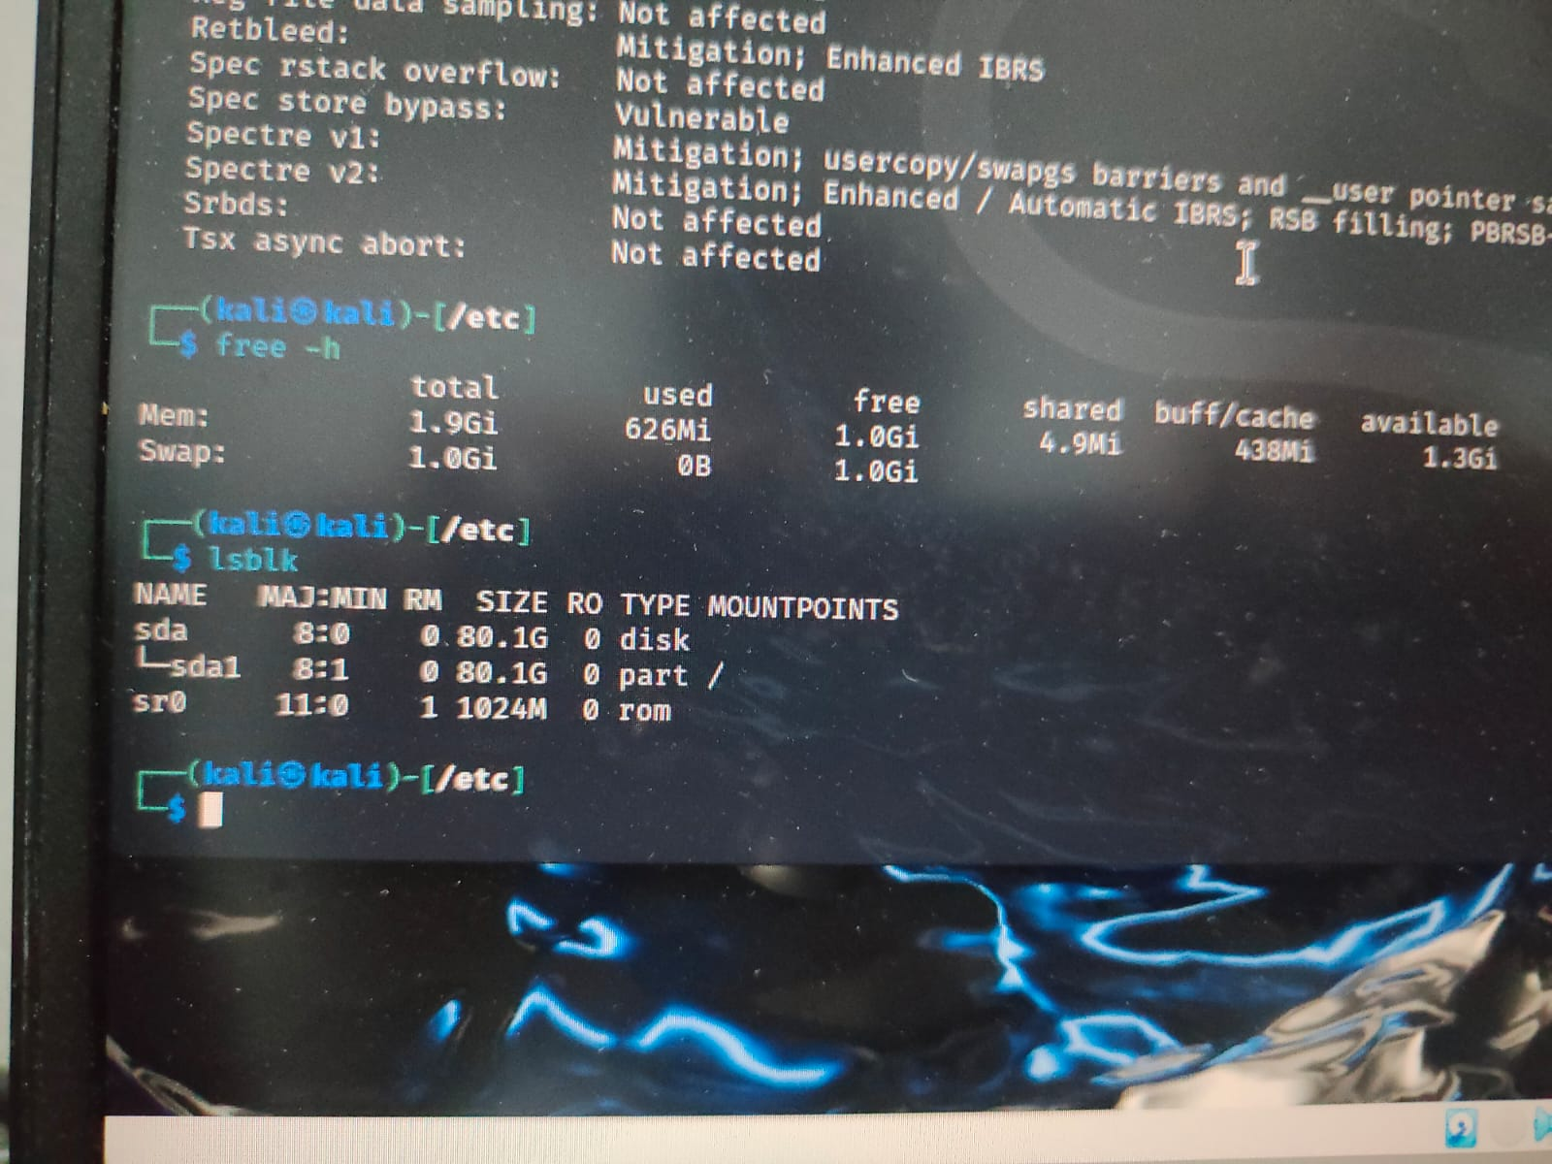

1. ps aux

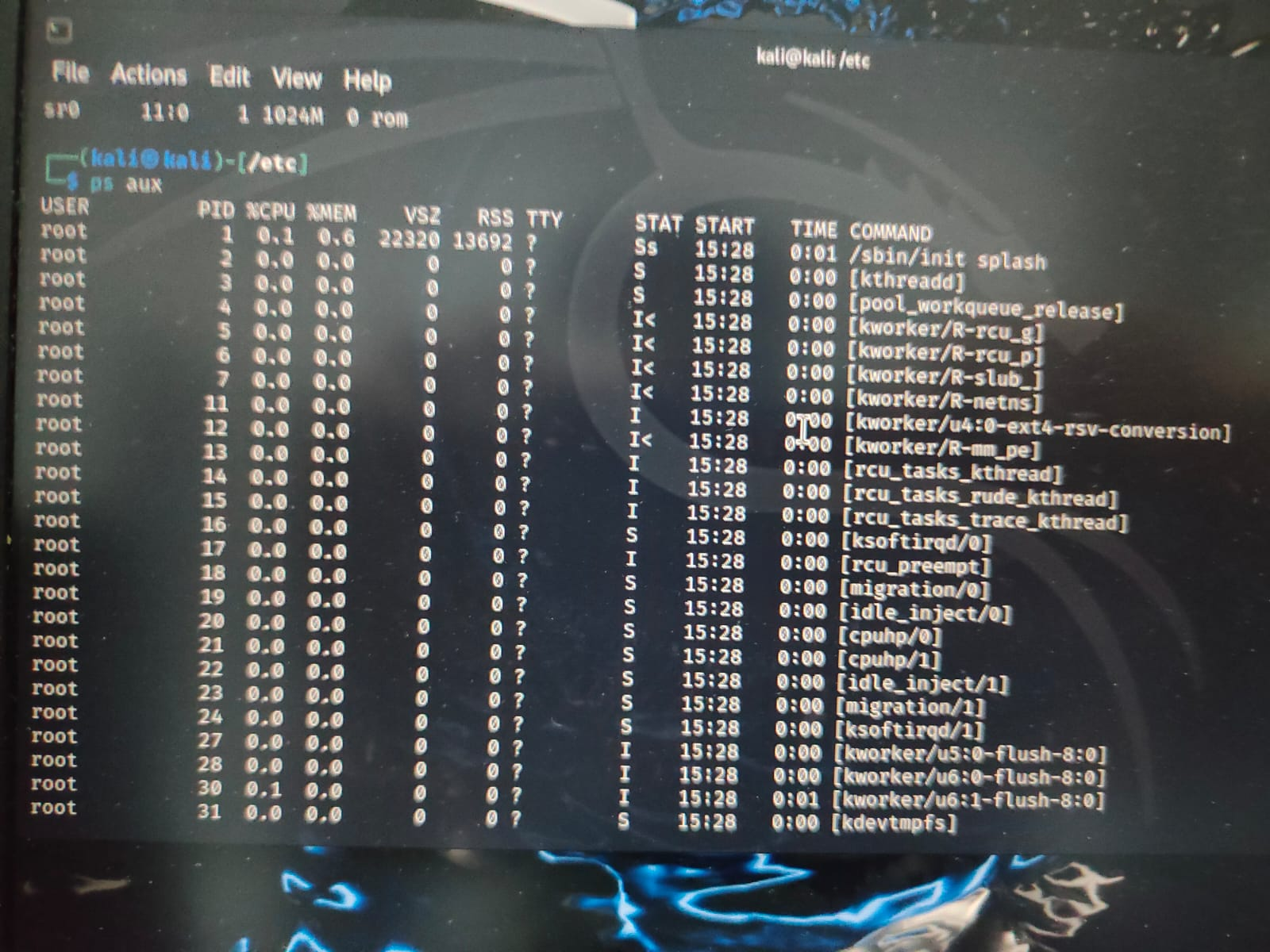

1. Write a script for generating random 8-character passwords including alpha numeric characters

ANS. 14)

chars= “abcdefghijklmnopqrstuvwxyzABCDEFGHIJKLMNOPQRSTUVWXYZ123456789”

password= “ ”

for i in {1..8}

do

password =${chars : RANDOM%${chars}:1}

done

echo “Generated password: $password”

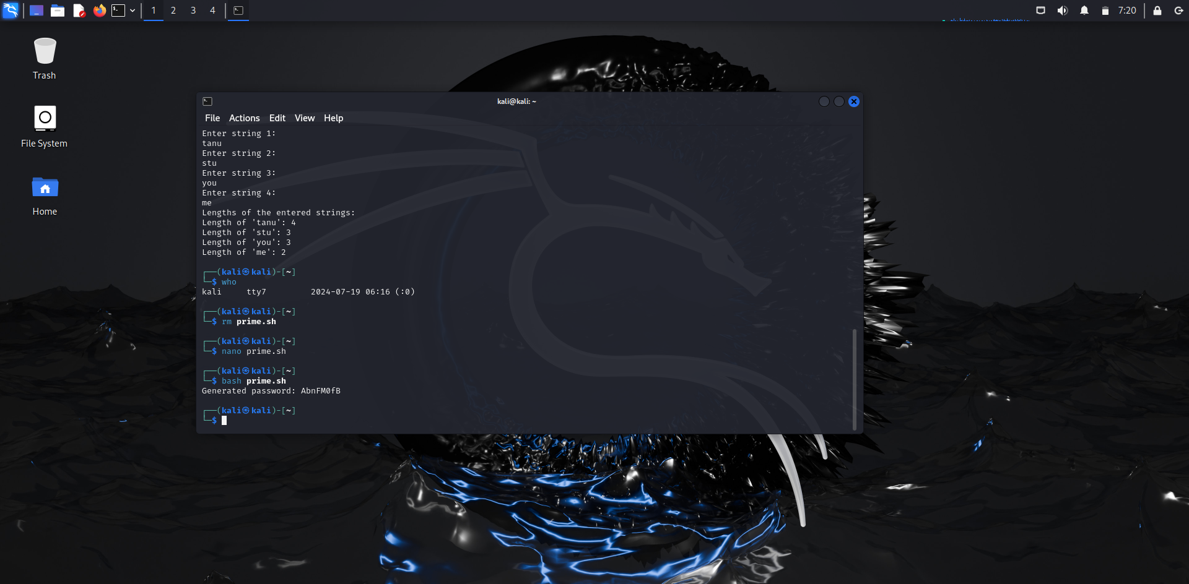

1. List all Files that has exactly 3 Characters Present in Current Working Directory?

ANS. 15) We will type the command :

ls ???

to get the files which exactly contains 3 characters

The files in my system in current directory which has exactly 3 characters are:

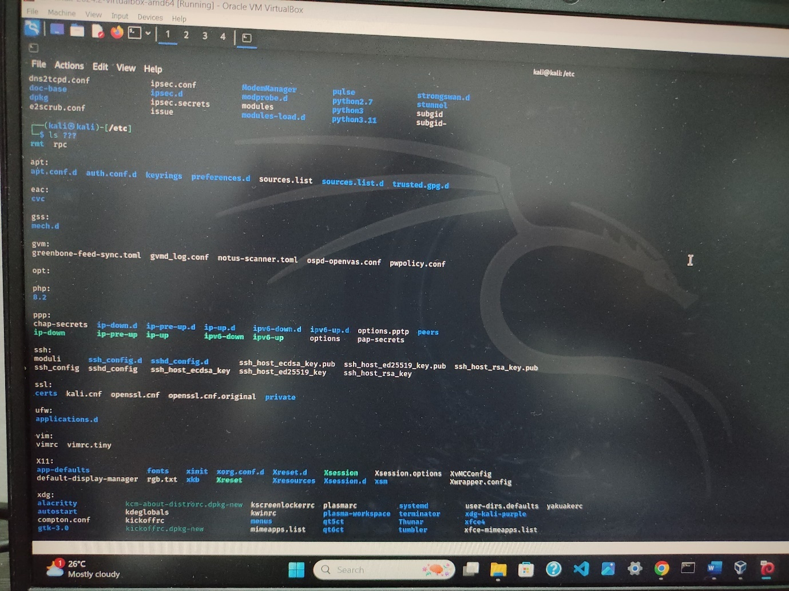

1. Display Contents of all Files that begins with a Digit and Ends with Letter a OR e OR i OR o OR u?

ANS. 16)

# Loop through all files in the current directory that match the pattern

for file in [0-9]*[aeiou]; do

# Check if it's a regular file

if [ -f "$file" ]; then

echo "Displaying contents of $file:"

cat "$file"

echo

fi

done

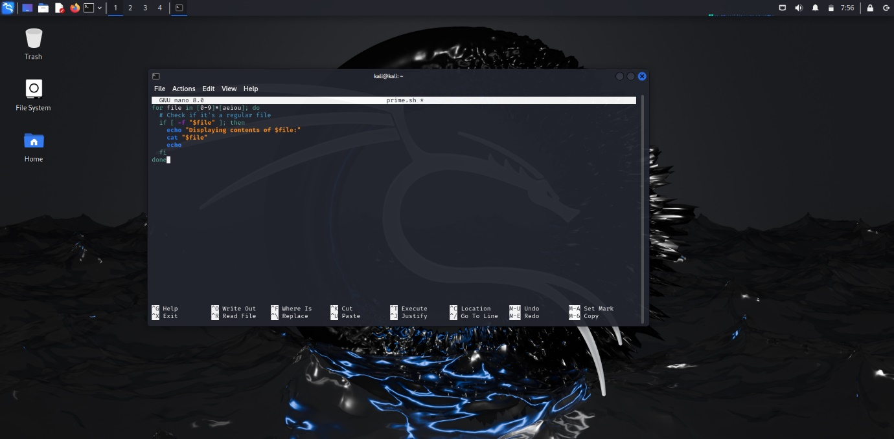

(No file matches the criteria given in question for the current directory)

1. How to Delete Blank Lines Present in the given File?

ANS. 17) For example we have file abc.txt

abc.txt contains the following content:

Tanishq

KANARE

Student

By using grep command, we can remove the empty lines from the file:

grep -v '^$' abc.txt > stu.txt

This command will created a new stu.txt file and the contents of this file are without empty lines which are as follows:-

Tanishq

KANARE

Student

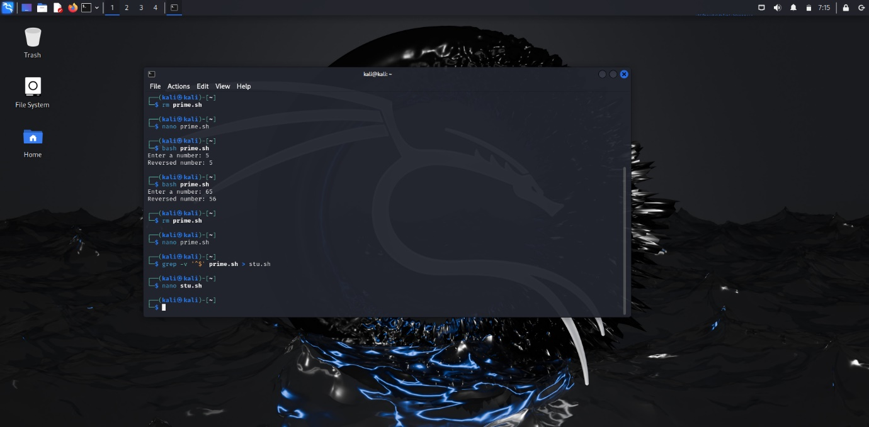

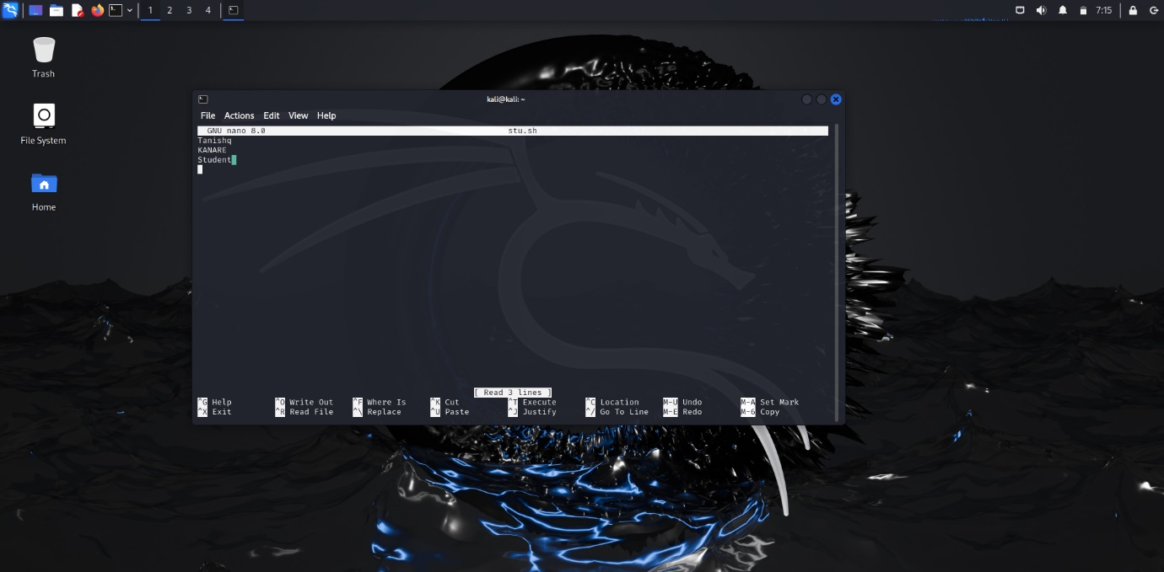

1. Write Commands to Count the Number of Directories Present in the Current Working Directory?

ANS. 18) The commands are as follows:

find . -maxdepth 1 -type d | wc -l

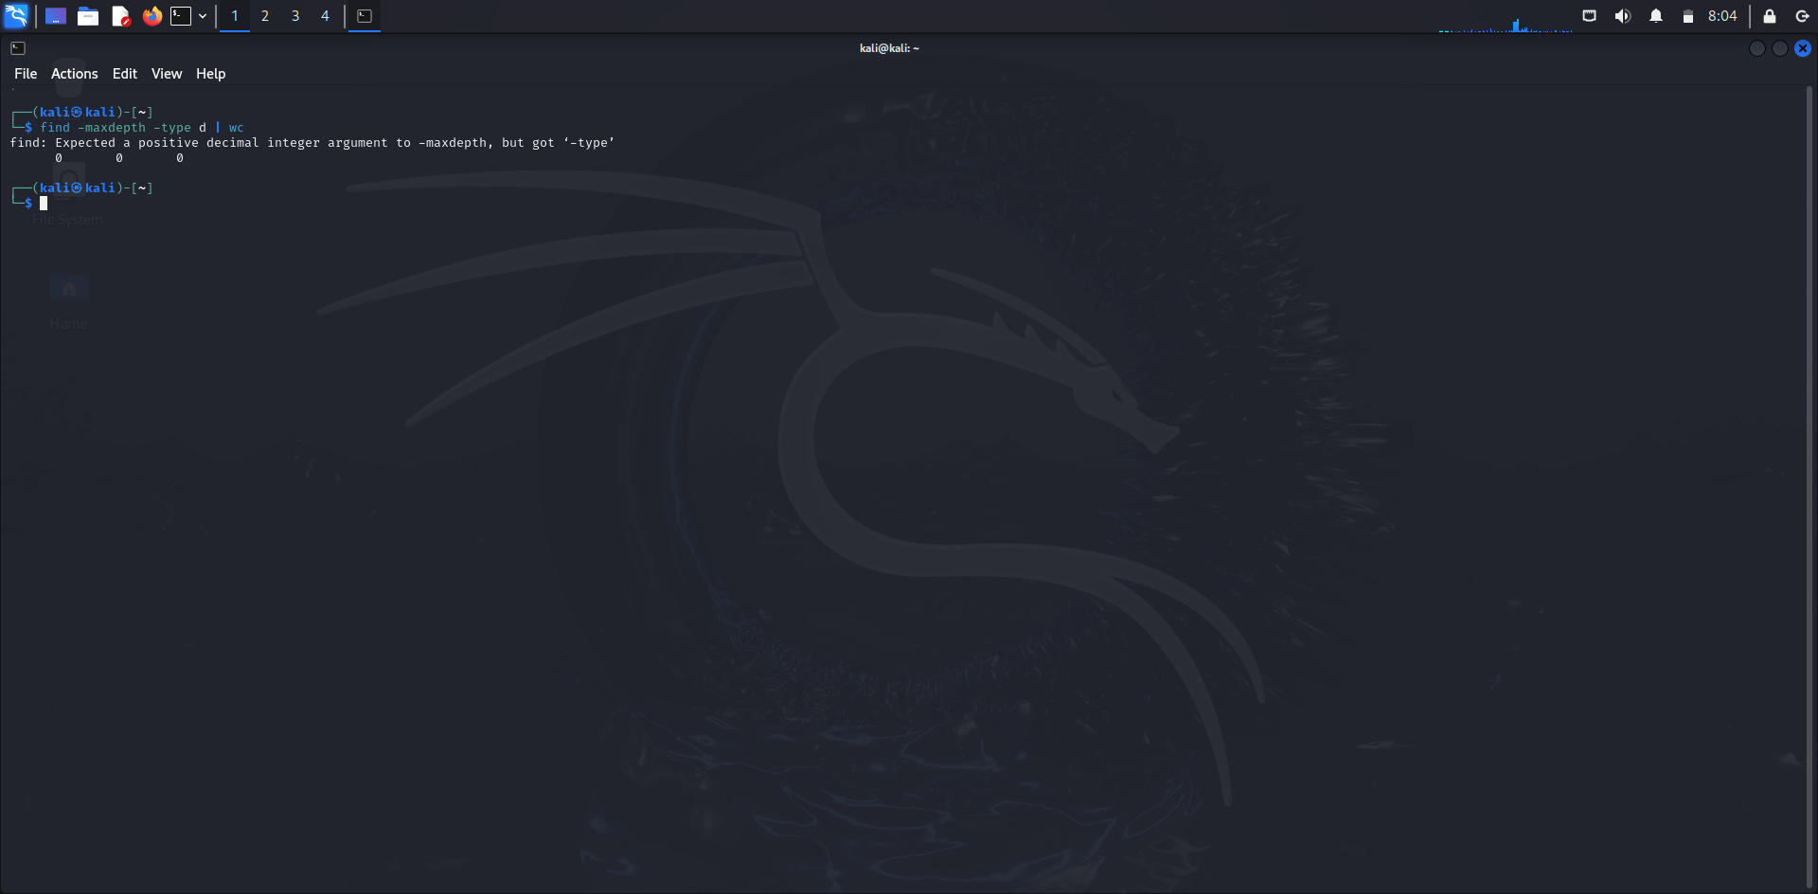

1. Write Script to Create Log File with Timestamp

Ans. 19

Create a timestamp

timestamp=$(date +"%Y%m%d_%H%M%S")

# Define the log file name

logfile="log_$timestamp.txt"

# Create the log file and add an initial log entry

echo "Log file created at $(date)" > "$logfile"

# Output the name of the log file

echo "Log file created: $logfile" (date)" > "$logfile" # Output the name of the log file echo "Log file created: $logfile"

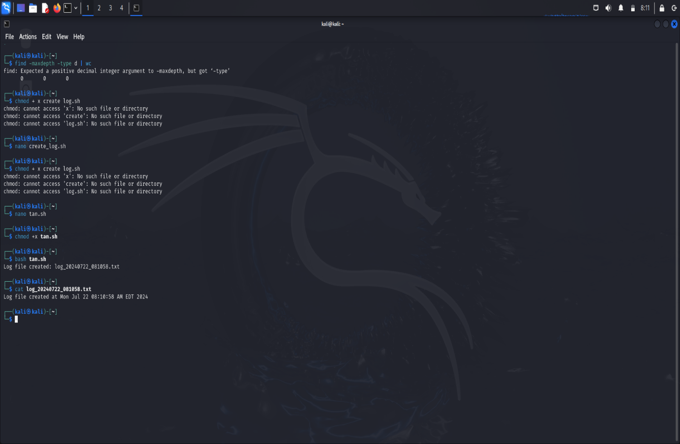

1. Write a Script to Read Student Data and display to the Console for Confirmation?

ANS. 20)

# Function to read and display student data

read_student_data() {

# Read student name

echo -n "Enter student name: "

read student_name

# Read student age

echo -n "Enter student age: "

read student_age

# Read student grade

echo -n "Enter student grade: "

read student_grade

# Display student data for confirmation

echo

echo "Please confirm the entered student data:"

echo "Name : $student_name"

echo "Age : $student_age"

echo "Grade: $student_grade"

echo

}

# Main script execution

read_student_data

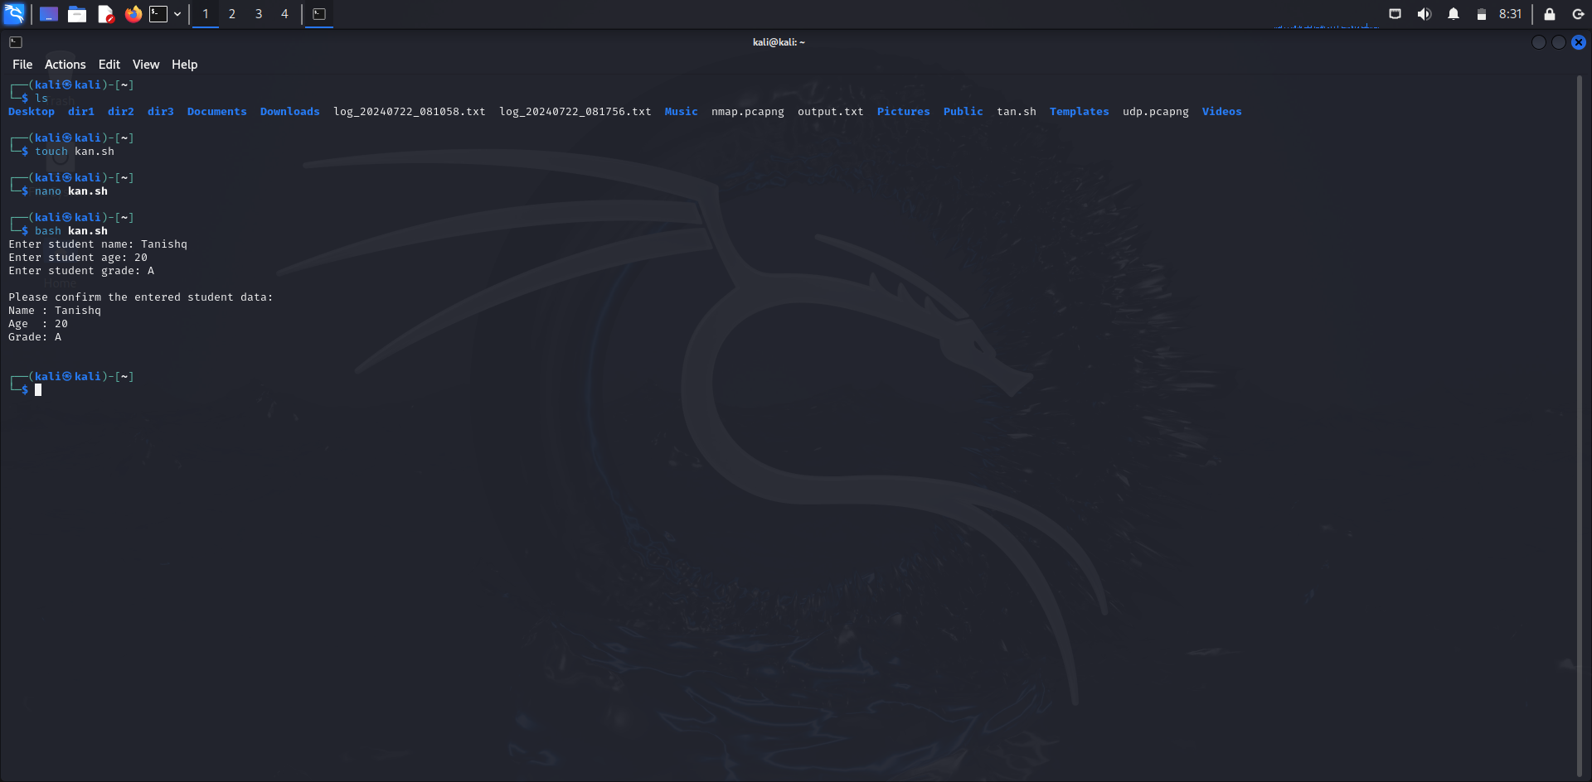

1. Write a Script to find Greater of 5 Numbers?

ANS. 21)

read -p “enter number 1: ” a

read -p “enter number 2: ” b

read -p “enter number 3: ” c

read -p “enter number 4: ” d

read -p “enter number 5: ” e

if[$a -gt $b -a $a -gt $c -a $a -gt $d -a $a -gt $e]

then

echo “$a is the largest of 5 numbers”

elif [ $b -gt $c -a $b -gt $d -a $b -gt $e]

then

echo “$b is the largest”

elif [$c -gt $d -a $c -gt $e]

then

echo “ $c is the largest”

elif [$d -gt $e]

then

echo “$d is the largest”

else

echo “$e is the largest”

fi

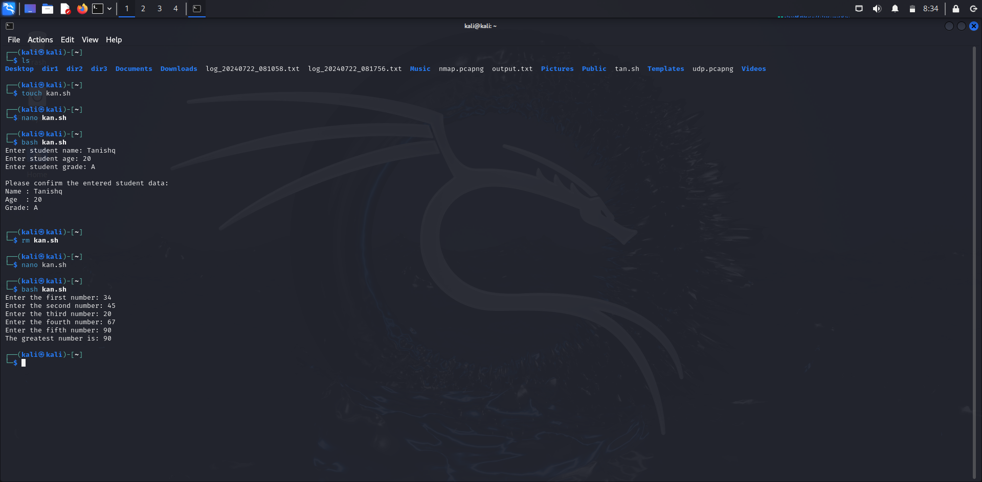

1. Write a Script that Accepts 2 File Names and Check whether both Files having same Content OR not?

Ans. 22)

check_file_content() {

# Read the file names from the user

echo -n "Enter the first file name: "

read file1

echo -n "Enter the second file name: "

read file2

# Check if both files exist

if [ ! -f "$file1" ]; then

echo "File '$file1' does not exist."

exit 1

fi

if [ ! -f "$file2" ]; then

echo "File '$file2' does not exist."

exit 1

fi

# Compare the contents of the two files

if cmp -s "$file1" "$file2"; then

echo "Both files have the same content."

else

echo "Files have different content."

fi

}

# Main script execution

check_file_content

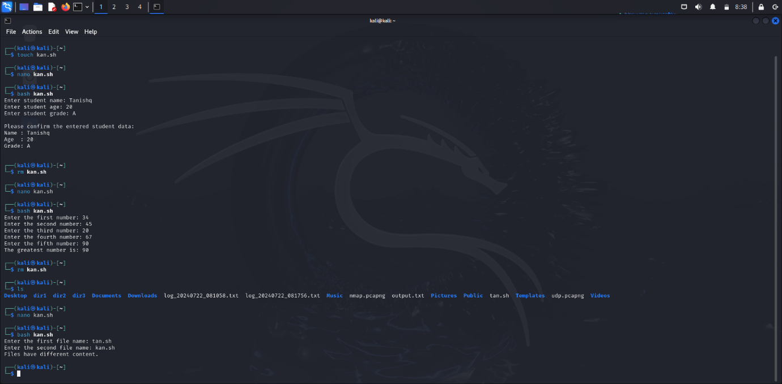

1. Write a Script that Accepts a File Name and Display User Permissions?

Ans. 23)

# Function to display user permissions for a file

display_permissions() {

# Read the file name from the user

echo -n "Enter the file name: "

read file

# Check if the file exists

if [ ! -f "$file" ]; then

echo "File '$file' does not exist."

exit 1

fi

# Get the file permissions and owner

permissions=$(stat -c "%A" "$file")

owner=$(stat -c "%U" "$file")

# Display file permissions and owner

echo "File: $file"

echo "Permissions: $permissions"

echo "Owner: $owner"

}

# Main script execution

display_permissions

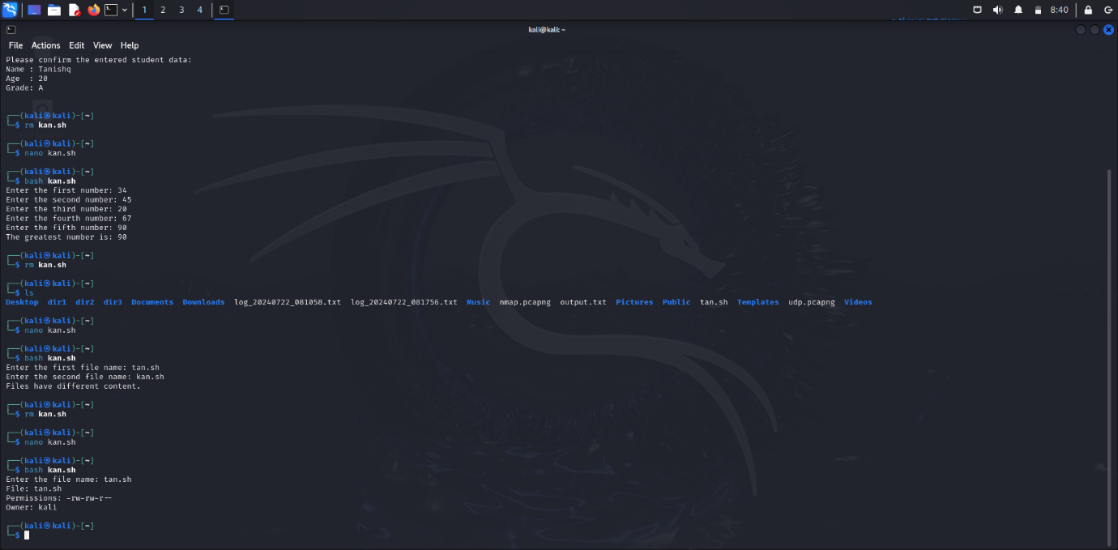

1. Write a script to read a number from 0 to 9 and print equivalent English word?

Ans. 24)

Read -p “enter a number from 0 to 9: ” num

If [num -eq 0]

Then

Echo “Corresponding word is ZERO”

Elif [num -eq 1]

Then

Echo “ ONE”

Elif [num -eq 2]

Then

Echo “ TWO”

Elif [num -eq 3]

Then

Echo “ THREE”

Elif [num -eq 4]

Then

Echo “ FOUR”

Elif [num -eq 5]

Then

Echo “ FIVE”

Elif [num -eq 6]

Then

Echo “ SIX”

Elif [num -eq 7]

Then

Echo “ SEVEN”

Elif [num -eq 8]

Then

Echo “ EIGHT”

Elif [num -eq 9]

Then

Echo “ NINE”

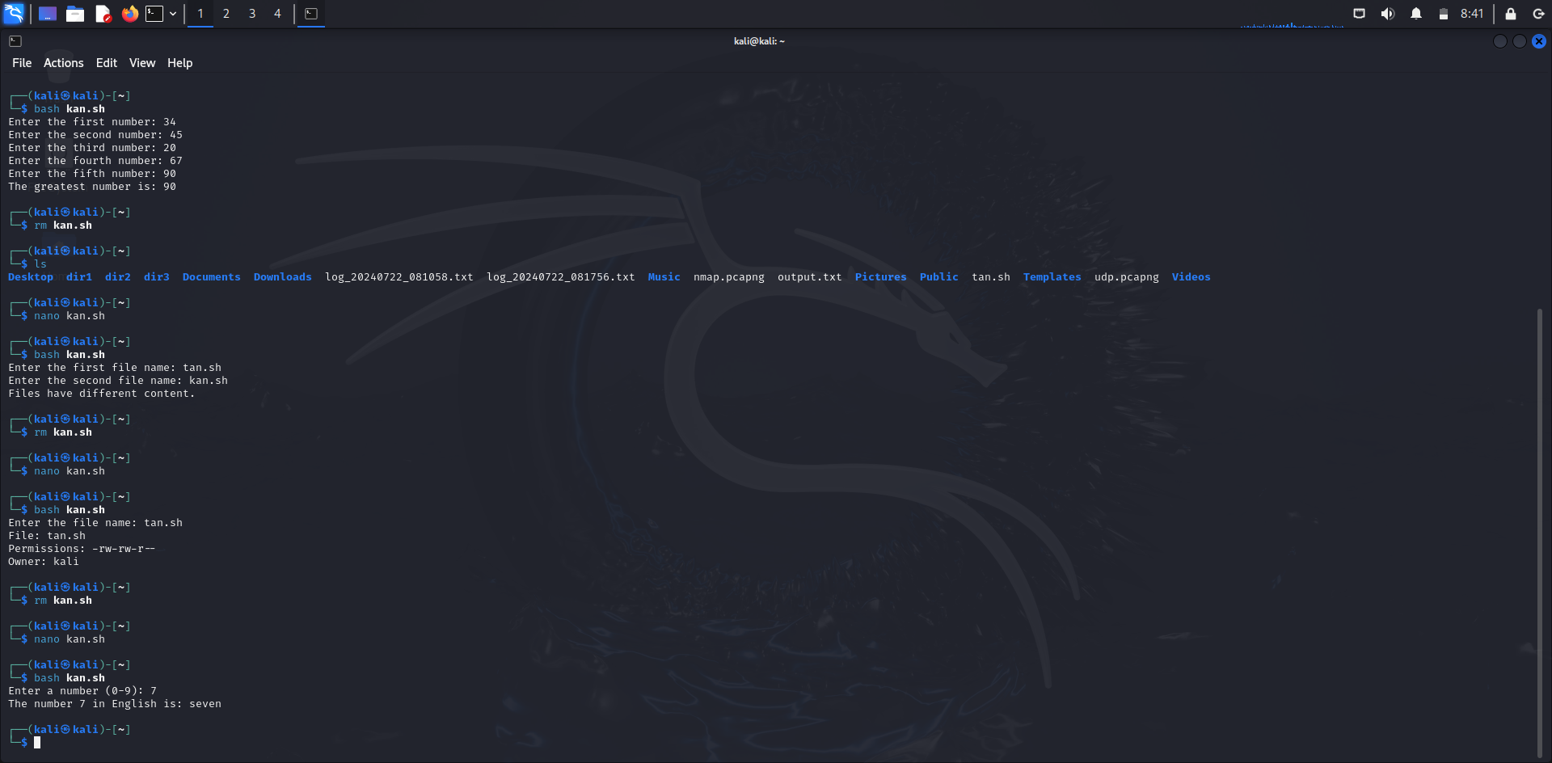

1. Write a Script that Accepts a Single Character and Checks whether it is Digit OR Special Character OR Vowel OR Consonant?

ANS. 25)

# Function to classify a single character

classify_character() {

# Read a single character from the user

echo -n "Enter a single character: "

read -n 1 char

echo # Move to a new line after reading the character

# Validate input length

if [ ${#char} -ne 1 ]; then

echo "Invalid input. Please enter exactly one character."

exit 1

fi

# Check if the character is a digit

if [[ "$char" =~ [0-9] ]]; then

echo "$char is a digit."

return

fi

# Check if the character is a vowel

if [[ "$char" =~ [aeiouAEIOU] ]]; then

echo "$char is a vowel."

return

fi

# Check if the character is a consonant

if [[ "$char" =~ [bcdfghjklmnpqrstvwxyzBCDFGHJKLMNPQRSTVWXYZ] ]]; then

echo "$char is a consonant."

return

fi

# Check if the character is a special character

if [[ "$char" =~ [^a-zA-Z0-9] ]]; then

echo "$char is a special character."

return

fi

# If none of the above, it is an unknown character

echo "$char is an unknown character."

}

# Main script execution

classify_character

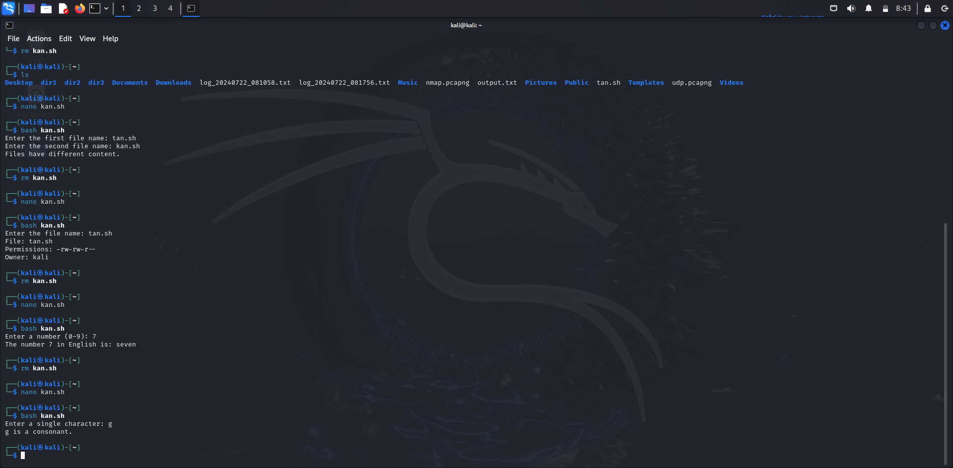

1. Write a Script to generate Hotel Bill based on Customer selected Items. The Items and Price Information is as follows A → Vadapov (Each Plate Rs 30 /-) B → Dosa (Each Plate Rs 50 /-) C → Poori (Each Plate Rs 40 /-) D → Idli (Each Plate Rs 25 /-)

Ans.)

# Function to generate the hotel bill

generate_bill() {

# Prices of items

price_vadapov=30

price_dosa=50

price_poori=40

price_idli=25

# Read quantities from the user

echo -n "Enter the quantity for Vadapov (Rs 30 each): "

read quantity_vadapov

echo -n "Enter the quantity for Dosa (Rs 50 each): "

read quantity_dosa

echo -n "Enter the quantity for Poori (Rs 40 each): "

read quantity_poori

echo -n "Enter the quantity for Idli (Rs 25 each): "

read quantity_idli

# Calculate totals for each item

total_vadapov=$((quantity_vadapov * price_vadapov))

total_dosa=$((quantity_dosa * price_dosa))

total_poori=$((quantity_poori * price_poori))

total_idli=$((quantity_idli * price_idli))

# Calculate grand total

grand_total=$((total_vadapov + total_dosa + total_poori + total_idli))

# Display the bill

echo

echo "Hotel Bill:"

echo "-----------------------------"

echo "Vadapov (x$quantity_vadapov) : Rs $total_vadapov"

echo "Dosa (x$quantity_dosa) : Rs $total_dosa"

echo "Poori (x$quantity_poori) : Rs $total_poori"

echo "Idli (x$quantity_idli) : Rs $total_idli"

echo "-----------------------------"

echo "Total : Rs $grand_total"

}

# Main script execution

generate_bill

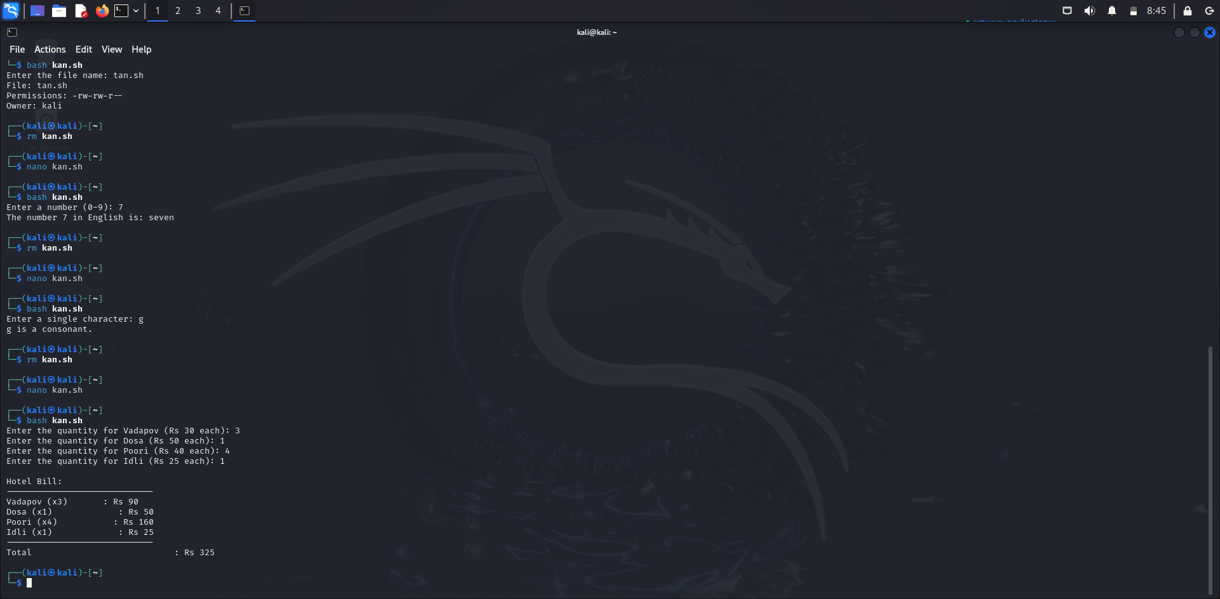

1. Write a Script to Read n Numbers and Store inside Array. Print the Sum of Even Numbers and Odd Numbers separately?

Ans. )

# Function to calculate and print the sum of even and odd numbers

calculate_sums() {

# Read the number of elements

echo -n "Enter the number of elements: "

read n

# Initialize arrays and sum variables

numbers=()

sum_even=0

sum_odd=0

# Read numbers from the user

echo "Enter $n numbers:"

for ((i = 0; i < n; i++)); do

echo -n "Number $(($i + 1)): "

read number

numbers+=($number)

done

# Calculate sums of even and odd numbers

for number in "${numbers[@]}"; do

if ((number % 2 == 0)); then

sum_even=$((sum_even + number))

else

sum_odd=$((sum_odd + number))

fi

done

# Display results

echo

echo "Sum of even numbers: $sum_even"

echo "Sum of odd numbers: $sum_odd"

}

# Main script execution

calculate_sums

